Synopsis for Mini Project
On
Online Voting System
Submitted in partial fulfillment of the requirements for the award of degree of
BACHELOR OF TECHNOLOGY
In

COMPUTER SCIENCE & ENGINEERING

Department of Computer Science and Engineering
National Institute of Technology, Uttarakhand
Spring Semester 2016
Subject Coordinator:

Mr. Navjot Singh
Associate Dean, Research & Consultancy and Assistant Professor
Department of Computer Science and Engineering

Submitted to: Submitted by:
Mr. Praveen Kumar Vijay Kumar Prajapat (BT13CSE036)
Assistant Professor Dept. Of CSE Rahul Pal (BT13CSE042) Harish rathore (BT13CSE027)
Nitesh Chaudhary (BT13CSE034)

Software Requirements Specification

Introduction
- Online Voting System(OVS) is a web based application.
- OVS is a voting software.
- It consists of four groups, namely -
- General voter.
- Candidate/Nominee.
- Inspector.
- Administrator.

Purpose
This Software Requirements Specification (hitherto referenced as SRS) document describes the behavior and requirements of the “Online Voting System” software package.

Scope
This SRS document applies to the “Online Voting System” software package.
- Secured login procedure
- .Knowing nominees of respective wards
- .Profiles can be modified
- .Nominees can post their vision
- .Casting vote is possible only with successful authentication of voter
- .Inspection is performed on both voter and nominee
- Suspected user can be reported against.
- Abused users can be verified and blocked if necessary
1.3 Overview
The remainder of this document identifies the actors, use-cases, use-case scenarios, activity diagrams, assumptions and dependencies needed for the analysis and design of the “Online Voting System” software package. All diagrams conform to UML standards.

2 Overall Description
2.1 ER Diagram

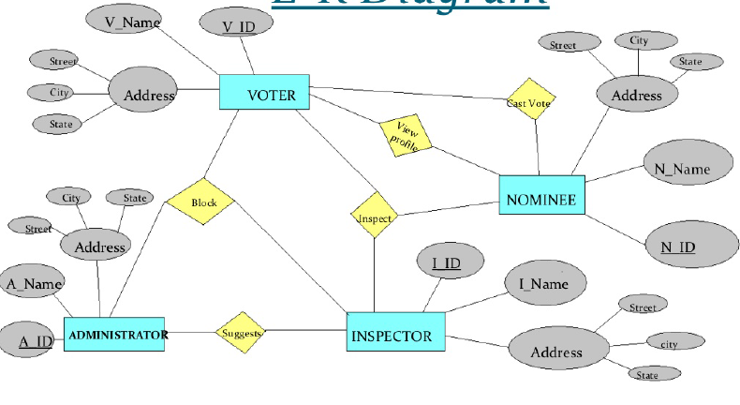

Fig:- ER Diagram of OVS Use-Case Model Survey

2.2 Use-Case Model Survey

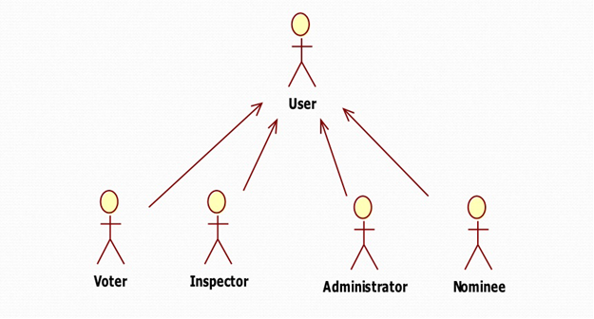

Figure 1 – Online Voting System User-Case Diagram

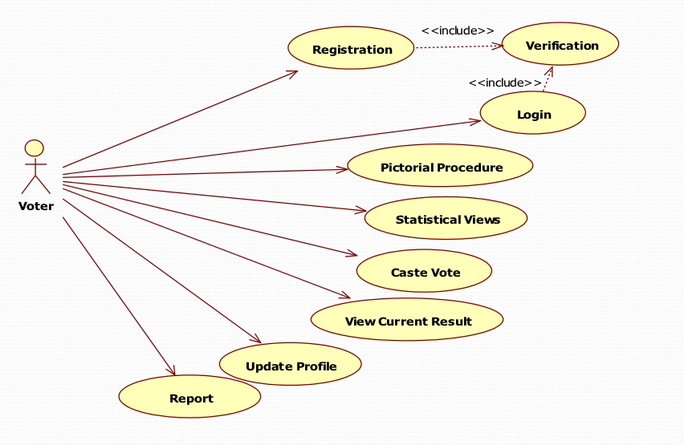 Figure 2 – Online Voting System Voter-Case Diagram
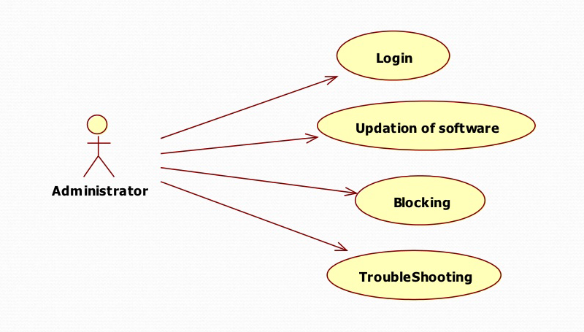

Figure 3 - Online Voting System Administrator -Case Diagram

3. Sequence Diagrams

3.1 Login Process

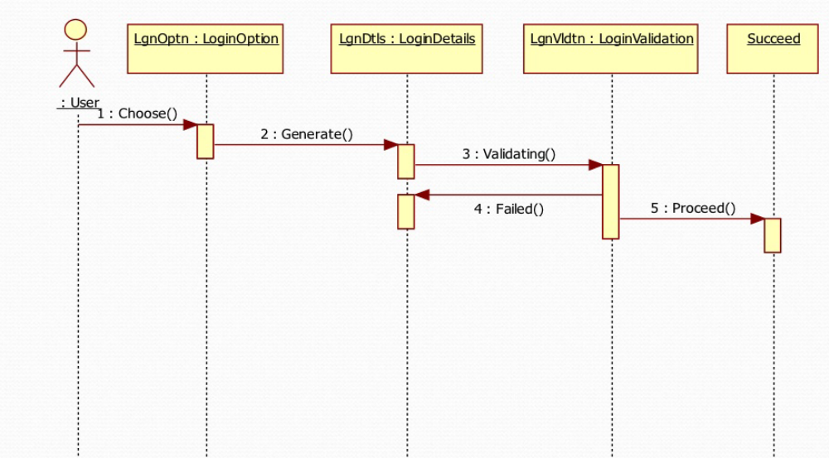

Firstly user will visit on online voting web site and there he/she will see login option for ballot.
Now user will fill required entries to login. Then browser will request to validate filled entries.
Now back end side will check validation then corresponding message will be displayed at end user side.

3.2 Voting Process

Now after validation, if user is valid then voting process comes under process. Voter will vote for all nominees to whom he/she wants to vote for all the posts. In this process user will submit voted form and the website will take all the data entered by voter. This data will be entered in database automatically.
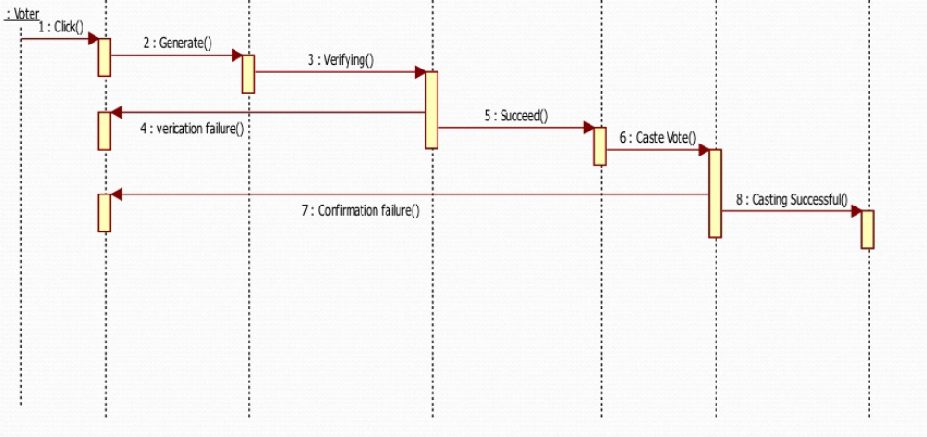3.3 Reporting Suspected Users
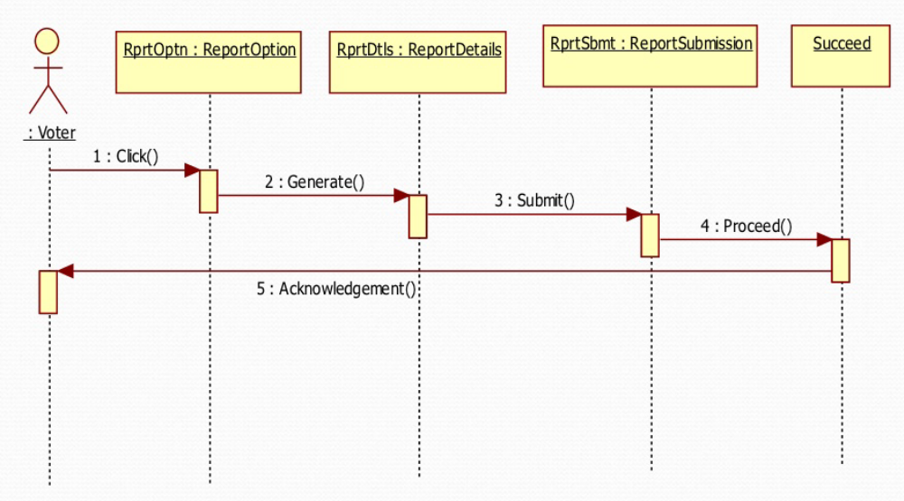
For example, if any student tries to access an identity which was enrolled but student left college after enrollment, now this roll no. does not exist then we have to report for this user.

3.3 Updating Result

Our website will be able to view result during voting process. When a user wants to check total no. of votes, then he/she can check result by clicking a button “See Current Results”.

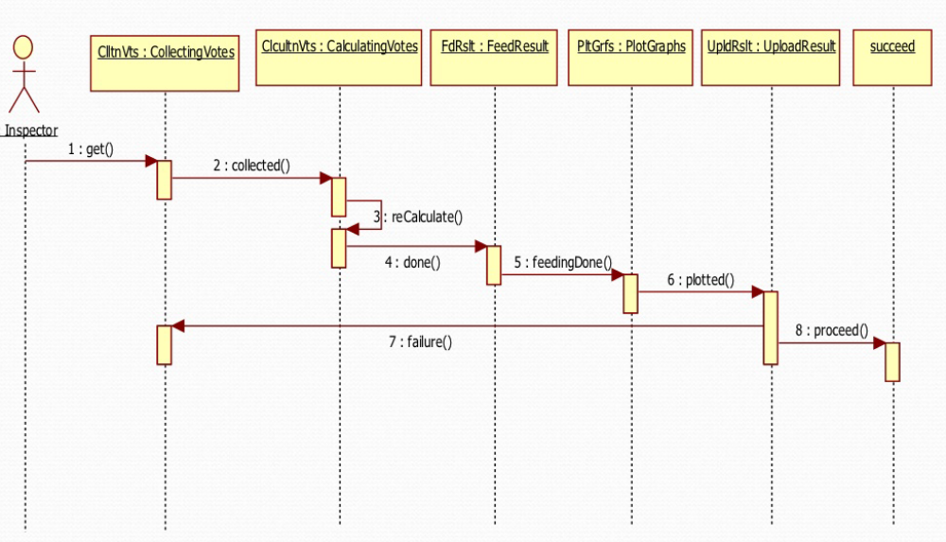

3.4 Result Viewing

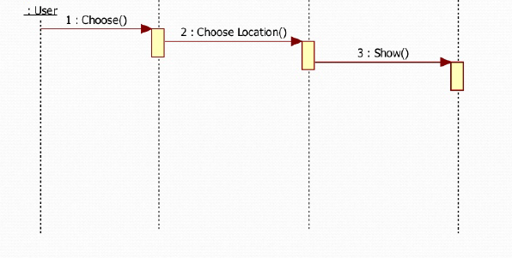

So far if all the processes have been completed successfully. Now the time is to

Increase heartbeat of nominees that is result announcement of whole process. Results

Will also be shown during voting. This will be final result.

4. Testing Performed:-

- System Test
- Performance Test
- Security Test
- Automated Test
- Documentation Test
- User Acceptance Test

5. Specific Requirements

5.1 Functionality
- Activation will not be explicitly required for access to online help and voter information. Both options shall be available at any time during the general use of the system by a voter.
- The system will not allow multiple selections for the same ballot question
- During the voting process, the system will not provide a means by which a voter may go back to amend previous choices.
- The administrative functions of the system will not be visible to the voter at any time. Access to such information, and the related login screens, will only be possible through special means.
5.2 Usability
- A voters may only ballot if they are eligible to vote.
- A voter may only one ballot per post.
5.3 Reliability
- The “Online Voting System” website will be available for voter use only during normal poll hours. During this time it shall be operational for as long as is possible.
- Administrators will have 24 hour access to the system.
5.4 Performance
- The “Online Voting System” website package will perform all functions with minimal delay from the time of the initial request.
- The website will accommodate multiple user at a time.
5.5 Supportability
The “Online Voting System” website shall have a clear and easily maintainable interface for managing election specific updates.

5.6 Design Constraints

Due to the sensitive nature of the information handled by the “Online Voting System” website, a good deal of specific design constraints will be taken into consideration:
- The system shall only have the ability to write vote data and to see results.
- The system shall not have the ability to overwrite any previously written vote data.
- Ballot information cannot be changed once a vote has been cast.
5.7 Purchased Components

Domain should be purchased to use it.

5.8Interfaces

5.8.1 User Interfaces

The “Online Voting System” website will be easy to use.

5.8.2 Hardware Interfaces

There is no need of special hardware.

5.8.3 Licensing Requirements

None.

5.8.4 Legal, Copyright and Other Notices

None.

5.8.5 Applicable Standards

None.

Thank you !!

